Internship report on

**Realization of prototype model of process automation system using Raspberry Pi**

Work carried at Submitted by

**CCS/LSSF/SDSC SHAR Ch. Sai Manideep – (19BEC0178)**

**DEPARMENT OF ECE**

**VELLORE INSTITUTE OF TECHNOLOGY**

**VELLORE**

**ACKNOWLEDGEMENT**

I express my sincere thanks to **Mrs. A. Latha**, Deputy General Manager, CCS/LSSF for giving this opportunity to do internship work in this prestigious organization.

I take this opportunity to express my sincere thanks and regards to my guide **Mrs.S.V.Suryakala**, Engineer - SE, CCS/LSSF for her valuable guidance and encouragement during the entire work. Her suggestions have raised the quality of the product to a level that would have been otherwise impossible. I would also like to convey my special thanks to **Mr. Naveen Kumar**, Engineer – SD ICS/LSSF for his continuous support that proved to be an excellent and invaluable asset throughout the development period.

I sincerely thank them for sparing their valuable time quite often, in spite of their heavy workload. The discussions I had with them gave me great insight into what had to be done. Last, but not the least, I like to express my deep gratitude to SDSCSHAR for providing the required technical support for the project.

**Signature Of Guide**

**ABSTRACT**

Main objective of this internship is to study the working of a process automation system and replicate the functionality with the help of Raspberry PI using MODBUS protocol.

Since Failure of any component will affect the launch. Every component will have redundancy at each level including the PLC. Adding on the factors like safety, availability, criticality it loses its viability. Based on our requirements we were able to realize the entire network of process automation system using financially viable options while striving to improve the performance of the said system.

**CONTENTS**

**1. ORGANIZATION PROFILE** 6

1.1 ISRO 6

1.2 SDSC SHAR 7

1.3 LSSF 12

**2. CONTROL SYSTEMS** 14

2.1 INTRODUCTION 14

2.2 TYPES OF CONTROL SYSTEM 15

2.2.1 OPEN LOOP SYSTEM 15

2.2.2 CLOSED LOOP SYSTEM 16

2.2.2.1 PROPORTIONAL CONTROL 18

2.2.2.2 INTEGRAL CONTROL 19

2.2.2.3 DIFFERENTIAL CONTROL 19

2.2.2.4 PID CONTROL 20

2.3 PROCESS AUTOMATION SYSTEM 21

**3. PROGRAMMABLE LOGIC CONTROLLER** 23

3.1 INTRODUCTION 23

3.2 PLC CYCLE 25

3.3 PARTS OF PLC 26

3.4 CHARACTERISTICS OF PLC 27

3.5 MERITS OF PLC 27

3.6 DEMERITS OF PLC 28

3.7 APPLICATIONS OF PLC 28

**4. I/O MODULES** 29

4.1 INTRODUCTION 29

4.2 ANALOG SIGNALS 31

4.3 DIGITAL SIGNALS 32

**5. SCADA** 34

5.1 INTRODUCTION 34

5.2 SUB SYSTEMS 36

5.3 FUNCTIONS OF SCADA 38

5.4 APPLICATIONS 39

5.5 ADVANTAGES 40

5.6 DISADVANTAGES 41

**6. INSTRUMENTATION** 42

6.1 DEFINITION 42

6.2 PRESSURE MANAGEMENT 42

6.3 TEMPERATURE MANAGEMENT 45

6.4 FLOW MANAGEMENT 47

6.5LEVEL MANAGEMENT 48

**7.PROJECT** 50

**1. ORGANIZATION PROFILE**

**1.1 ISRO**

The Indian Space Research Organization is the primary space agency of the Indian government. ISRO is amongst the six largest government space agencies in the world, along with NASA, RKA, ESA, CNSA and JAXA.

It is established in 1969, 15th August by Vikram Ambalal Sarabhai. Headquartered in Bangalore, ISRO is under the administrative control of the Department of Space, Government of India. Dr K Sivan is the present chairperson of ISRO.

The objective of ISRO is to develop space technology and its application to various tasks of national and international interest. Accordingly, it has successfully put into operation two major satellite systems, namely the Indian National Satellites (INSAT) for communication services and the Indian Remote Sensing (IRS) satellites for management for natural resources.

ISRO has achieved numerous milestones since its establishment. India’s first satellite, Aryabhata, was built by ISRO and launched by the Soviet Union in 1975. Rohini, the first satellite to be placed in orbit by an Indian-made launch vehicle, SLV-3, was launched in 1980. ISRO subsequently developed two other rockets: The Polar Satellite Launch Vehicle (PSLV) for putting satellites into polar orbits orbiting from north to South Pole and the Geosynchronous Satellite Launch Vehicle (GSLV) for placing satellites into geostationary orbits orbiting from west to east above equator. These rockets have launched numerous communications satellites, earth observation satellites. And in 2008, ISRO launched Chandrayaan-1, India’s first mission to the Moon. In 2013, ISRO launched its mars orbiter satellite from the SDSC SHAR, which is first Indian satellite to mars.

**1.2 SDSC SHAR**

Satish Dhawan Space Centre SHAR (SDSC SHAR), Sriharikota, the Spaceport of India, is one of the lead centres of Indian Space Research Organisation (ISRO), Department of Space (DOS), and Government of India. The Centre provides world class launch base infrastructure for national and international customers in accomplishing diverse launch vehicle/satellite missions for remote sensing, communication, navigation & scientific purposes and is one among the best-known names of the Spaceports of the world today. The space centre, which was popularly known as SHAR (Sriharikota Range) was renamed as Satish Dhawan Space Centre SHAR on September 5, 2002, in fond memory of Prof. Satish Dhawan, former Chairman of ISRO.

To venture on the indigenous development of satellites and their launch vehicles, it was decided to set up a rocket launch station on the East Coast of our country, far from populated areas. Features like a good launch azimuth corridor for various missions, nearness to the equator (benefiting eastward launches) and large uninhabited area for a safety zone have made Sriharikota the ideal location for the spaceport. It became operational on October 9, 1971 with the flight of ‘Rohini-125’, a small sounding rocket. Since then the facilities here were gradually expanded to meet the growing needs of ISRO.

Sullurupeta, a small town on the Chennai – Kolkata National highway (NH-5) towards the East, along the road laid across the Pullicat Lake takes one to Sriharikota. Sriharikota covers an area of about 43,360 acres (175sq.km) with a coastline of 50km.

**Major facilities at SHAR**:

1. **SPP**

Solid Propellant Plant produces the S200 Solid motors which is the third largest motors in the World. The plant is made flexible and versatile to make all kinds of Solid boosters of ISRO’s launch vehicles.

**2. SPROB**

Solid Propellant Space Booster Plant is involved in the production of solid propellant rocket motors used in ISRO’s launch vehicles.

**3. LSSF**

Liquid Propellant Storage and Servicing Facility is responsible for Propellant and gas servicing of liquid and cryo stages of PSLV, GSLV Mk-II and GSLV Mk -III during countdown.

**4. RO**

Range Operations Entity is primarily responsible for Range Instrumentation System. It also comprises of tracking by high precision radars right from the lift-off.

**5. VALF**

Vehicle Assembly and Launch Facilities (VALF) is responsible for stages/segments/sub-systems/Satellite preparation, Subsystems Integration, Vehicle Integration, Electrical & Checkout Operations and Launching of Major ISRO Launch vehicles.

**6. SR**

Systems Reliability (SR) Entity carries out Quality Assurance & Reliability Analysis for the activities in the areas of Solid Motor Production & Testing (SMPT), Launch Complex Operations (LCO), Propellant Servicing (PS) and Range Operations (RO).

It is also responsible for performing Quality Functions and ensuring flawless performance of all systems in SPROB, SPP, SMP & ETF, LSSF, VALF, CMG and RO at Satish Dhawan Space Centre, SHAR.



NAME : PSLV

HIEGHT: 4 m

DIAMETER: 2.8 m

NO OF STAGES: 4

LIFT OFF MASS : 320 tonnes

FIRST FLIGHT: Jan 24, 2019

NAME : GSLV MK - II

HIEGHT : 49.13 m

DIAMETER : 2.8 m

NO OF STAGES : 3

LIFT OFF MASS : 414.75 tonnes

FIRST FLIGHT : April 18,2001

****NAME : GSLV MK-Ⅲ

HIEGHT : 43.43 m

DIAMETER : 4 m

NO OF STAGES: 3

LIFT OFF MASS: 640 tonnes

FIRST FLIGHT : Dec18, 2014

**1.3 LSSF**

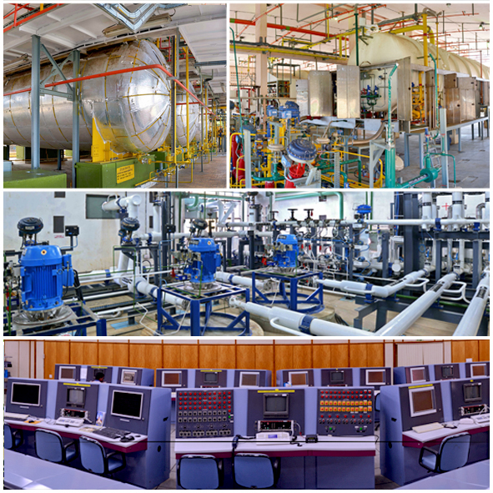

LSSF carries out the activities relating to storage and servicing of Earth storable propellants and Cryogenic propellants for the launch vehicles.

**Major facilities in LSSF:**

1. Earth Storable Propellant servicing systems (ESPS)
2. Cryo propellant systems (CPS)
3. Compressed Gas Systems (CGS)
4. Instrumentation & Control Systems (ICS)

Earth storable liquid propellants complex and cryo propellants complex forms two major facilities of LSSF. Earth storable Liquid propellant complex handles fuels like UDMH, MMH and oxidizers like N2O4, MON that are used in PSLV and GSLV missions. They are needed to be chilled and filled to the stages at specified temperature at controlled flow rate and pressure measured by instrumentation systems. Cryo stage is serviced only to GSLV and GSLV MKIII to lift off large ton satellites. It handles fuels like LH2 and oxidizers like LOX. They are to be filled very close to lift off to achieve defined accuracy of level, temperature and pressure due to low boiling point.

Since the boiling points of LH2 (-252 °C) and LOX (-182 °C) are very low, it is necessary to have super insulated storage tanks and pipe lines for handling these propellants.  These stages and ground systems require service fluids, such as Nitrogen, Helium and compressed air for commanding the valves, purging the systems, thermal conditioning of the stage etc.

PSLV is launched in 4 stages: 2 liquid stages (PS 2 and PS 4) and 2 solid stages. GSLV is launched in 3 stages: 1 cryo stage, 1 liquid stage (GS 2), 1 solid stage. Propellant filling and gas changing operation need to be carried out remotely, safely, and reliably. In view of above critical mission’s total prelaunch activities are carried out in automated environment. Filling process is controlled using E/P valves. It is also required to monitor/control the safety systems. These liquid stages need propellant storages and loading systems, stage propellant tank pressurization system, propellant drain system etc., at launch pad to service stages during last phase of countdown.

**2. CONTROL SYSTEMS**

**2.1 INTRODUCTION**

Cryo control system of Satish Dhawan Space Centre is mainly intended for total automation of pre-launch servicing of liquid stages of PSLV from First Launch Pad and GSLV Mk-II/GSLV Mk-III from Second Launch Pad remotely, safely and accurately.

**MAJOR FUNCTIONS OF CRYO CONTROL SYSTEM:**

* Acquisition and Processing of data from analog and digital signals of field sensors.
* Remote visualization of entire process during real time.
* Data logging and event / alarm generation.
* Remote monitoring and control of the processes with a reaction time of less than 1sec and provision to operate in discrete as well as in automatic mode as per pre-defined sequence.
* Surveillance monitoring and manual operating facility from Filling Control Centre (FCC) during real time operations to bring the process being controlled to a safe state.
* Control, monitoring, event/alarm logging, data archiving and report generation of all the processes from launch control centre with graphic mimic support.

**2.2 TYPES OF CONTROL SYSTEMS**

**2.2.1 OPEN LOOP SYSTEM**

The system which does not have any feedback loops connected to it is called Open loop feedback system. These types of systemsdon’t depend upon its output i.e. output is not used as the control variable for the system. Open loop systems are one-way signal flow systems.

As this system doesn’t contain feedback loops, these are also known as Non-feedback systems. As there is no feedback loop, no data is transferred back to the open loop systems.

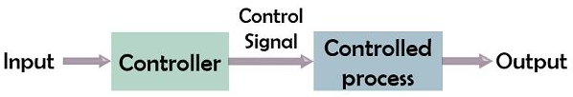

The output of the open loop system can be determined only by its present state input. There is no chance to correct the transition errors in open loop systems so there is more chance for errors to occur.

**Real time example of open loop system**

**Word processor**

This is also an open-loop control system. When the information is entered through a keypad, then the other blocks like [hardware components](https://www.watelectronics.com/major-electrical-electronic-components/) in the control system will process the information and displays it on LCD. When typing the peripheral is stopped by the operator then no input is given to the system so nothing will be displayed on LED. So word processor became an example of this control system.

### **Advantages of Open loop control System**

* The open loop systems are very simple and easy to design.
* These are cheaper in cost than any other type of control systems.
* Maintenance of open loop control system is very simple.
* These are stable for some extent of time.
* These types of systems are convenient to use.

### **Disadvantages of Open loop control System**

* The bandwidth of open loop control system is less.
* They do not facilitate the automation of process.
* Open loop systems are inaccurate in nature.
* As their output is affected by some of the external system disturbances, they are unreliable.
* It cannot correct the output deviations automatically.

**2.2.2 CLOSED LOOP SYSTEM**

A Closed loop control System also known as a feedback control system, is a control system which uses the concept of an open loop system as its forward path but has one or more feedback loops between its output and its input i.e some portion of the output is returned back to the input.

Closed-loop systems are designed to automatically achieve and maintain the desired output condition by comparing it with the actual condition. It does this by generating an error signal which is the difference between the output and the reference input. In other words, a closed-loop system is a fully automatic control system in which its control action being dependent on the output in some way.

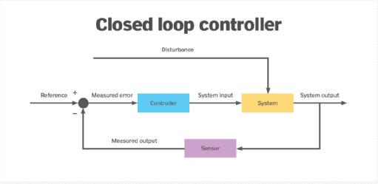

### **Real time example of closed loop system**

Modern Air Conditioner

Important closed loop control system example is a modern air conditioner.

Modern air conditioners are works in such a way that it has temperature and humidity measuring sensors. So it continuously monitors the temperature and humidity of the room. According to it, it turns on the compressor, adjusts the fan speed, etc.

**Advantages:**

* Closed loop control systems are more accurate even in the presence of non-linearity.
* The sensitivity of the system may be made small to make the system more stable.
* The closed loop systems are less affected by noise.

**Disadvantages:**

* Closed loop control systems are costlier and complex
* The feedback in the closed loop system may lead to oscillatory response
* The feedback reduces the overall gain of the system
* Stability is the major problem in the closed loop system and more care is needed to design a stable closed loop system.

**2.2.2.1 PROPORTIONAL CONTROL**

Proportional control, is a type of linear feedback control system in which a correction is applied to the controlled variable which is proportional to the difference between the desired value and the measured value

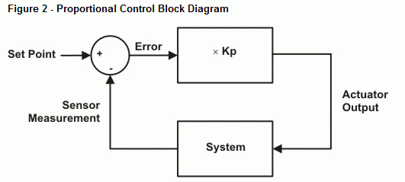



**Advantages**

* Easy to implement
* low cost
* Easy to tune the proportional constant

**Disadvantages**

* Responds only with change in error.
* Error cannot be reduced to zero.
* Fine controlling is not possible.

**2.2.2.2 INTEGRAL CONTROL**

Integral control is the control mode where the controller output is proportional to the integral of the error with respect to time. Integral action is provided by summing the error over time, multiplying that sum by a gain, and adding the result to the present controller output.

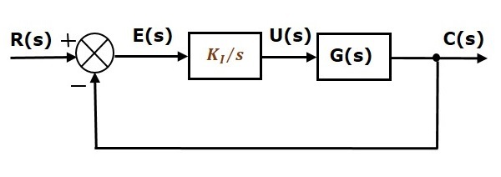

### **Advantages**

* Offset error can be eliminated.
* Overall system stability increases.

**Disadvantages**

* It is never used alone
* It tends to make the system unstable because it responds slowly towards the produced error.

**2.2.2.3 DIFFERENTIAL CONTROL**

Derivative controller action responds to the rate at which the difference between desired value and the measured value is changing that is derivative of the error.

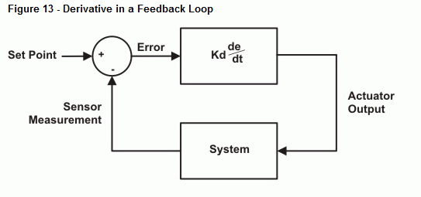

**Advantages**

* Peak errors are minimized.
* Derivative action is used to make the control faster.

**Disadvantages**

* Cannot be used when an error is constant. (Derivative of constant value is zero).
* It cannot be used alone.
* It does not eliminate steady state error.

**2.2.2.4 PID CONTROL**

A Proportional Integral Derivative controller calculates an error value {\displaystyle e(t)} as the difference between a desired set point (SP) and a measured process variable (PV) and applies a correction based on proportional, integral, and derivative terms (denoted *P*, *I*, and *D* respectively),

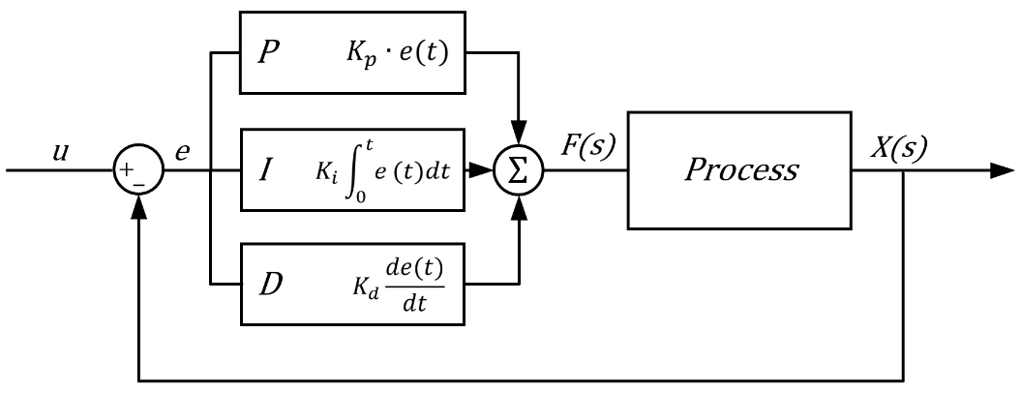

**Advantages**

* It provides better stability to the system.
* It is simple to design.
* It completely eliminates steady state error.
* It has good transient response.

**Disadvantages**

* Parameters setting for PID is difficult.
* Not optimal.
* Not dependent on process.

**2.3 PROCESS AUTOMATION SYSTEM**

The propellant filling process and its sub-processes need to be carried out by simultaneous control of various parameters like, pressure, temperature, flow rate, level etc., in both ground and stage systems. In order to carry out the propellant filling activities in a safe and reliable manner from remote location, a process automation system comprising of Programmable logical Controllers (PLC) and Supervisory Control and Data Acquisition (SCADA), with software and hardware implemented fault tolerance architectures is employed.



The control system is configured with Triple Modular Redundant (TMR) Controller with TMR distributed Remote I/O. The Liquid Stage Filling System (LSFS) consists of PLC systems and SCADA system. Four TMR PLC systems are configured at SLP for the automation of pre-launch operations during countdown. PLC IO modules are interfaced to ground based field sensors / elements through Instrumentation system. All Four PLCs with associated Remote IO systems are interconnected in a dual redundant network and extended to FCC for interfacing to SCADA system. The PLCs at the launch complex are interfaced to Supervisory Control and Data Acquisition (SCADA) system at the remote-control centre, located at FCC building, using dual redundant Fiber Optic Ring Network. The SCADA system is built using a Server-Client Architecture with two redundant Servers and 24 redundant client stations for display and operator interaction. 8 Clients are configured as Expert Display Stations, located at Expert Display Room of FCC, for providing necessary views for the system experts. The Network Connectivity from PLCs at PSLV complex to SCADA System at LCC is dual redundant. Each Network link is extended using two sets of FO Cable to LCC.

**3. PROGRAMMABLE LOGIC CONTROLLER**

**3.1 INTRODUCTION**

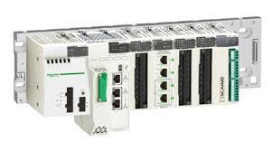

In a traditional industrial control system, all control devices are wired directly to each other according to how the system is supposed to operate. In a PLC system, however, the PLC replaces the wiring between the devices. Thus, instead of being wired directly to each other, all equipment is wired to the PLC. Then, the control program inside the PLC provides the “wiring” connection between the devices. The control program is the computer program stored in the PLC’s memory that tells the PLC what’s supposed to be going on in the system. The use of a PLC to provide the wiring connections between system devices is called soft wiring.

For example, let’s say that a push button is supposed to control the operation of a motor. In a traditional control system, the push button would be wired directly to the motor. In a PLC system, however, both the push button and the motor would be wired to the PLC instead. Then, the PLC’s control program would complete the electrical circuit between the two, allowing the button to control the motor.

The soft-wiring advantage provided by programmable controllers is tremendous. In fact, it is one of the most important features of PLCs. Soft-wiring makes changes in the control system easy and cheap. If you want a device in a PLC system to behave differently or to control a different process element, all you have to do is change the control program. In a traditional system, making this type of change would involve physically changing the wiring between the devices, a costly and time-consuming endeavour

For example, let’s say that two push buttons, PB1 and PB2, are connected to a PLC. Two pilot lights, PL1 and PL2, are also connected to the PLC. The way these devices are connected now is by pressing push button PB1, turns on pilot light PL1 and pressing push button PB2, turns on pilot light PL2. Let’s say that you want to change this around so that PB1 controls PL2 and PB2 controls PL1.In a traditional system, you would have to rewire the circuit so that the wiring from the first push button goes to the second pilot light and vice versa. However, because these devices are connected to a PLC, making this change is as simple as making a small change in the control program.

A PLC is a device that was invented to replace the necessary sequential relay circuits for machine control. The PLC works by looking at its inputs and depending upon their state, turning on/off its outputs. The user enters a program, usually via software, that gives the desired results.

A PLC is a CPU based electronic device used for automation of industrial process, such as control of machinery on industry. The input/output arrangements may be built into a single PLC or the PLC may have external I/O modules attached to a computer network that plugs into a PLC. The data handling, storage, processing, power and communication capabilities of some modern PLC's are approximately equivalent to desktop computer. PLC’s can be programmed using standard based programming languages.

PLC is a digitally operating electronic system, designed for use in an industrial environment, which uses a programmable memory for the internal storage of user-oriented instructions for implementing specific functions such as logic, sequencing, timing, counting and arithmetic, to control digital or analog inputs and outputs, various types of machines or processes. Both the PLC and its associated peripherals are designed so that they can be easily integrated in to an industrial control system and easily used in all their intended functions. A PLC is a user friendly, microprocessor based specialized computer that carries out control functions of many types and levels of complexity. Its purpose is to monitor crucial process parameters and adjust process operations accordingly. The PLC will operate any system that has output devices that go on and off. It can also operate any system with analog outputs.

**3.2 PLC CYCLE**

PLC operates in four stages. It takes 200ms to complete one cycle.

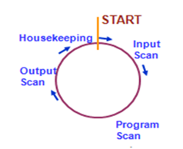

**1. Input Scan**

Scan the state of inputs.

**2. Program Scan**

Process the program logic.

**3. Output Scan**

Energize or de energizes the outputs.

**4. Housekeeping**

This step includes communications, Internal Diagnostics, etc.

**3.3 PARTS OF PLC**

Major parts of PLC:

* **Central processing unit (CPU)**

The central processing unit (CPU) is the part of a programmable controller that retrieves, decodes, stores, and processes information. It also executes the control program stored in the PLC’s memory. In essence, the CPU is the “brain” of a programmable controller. It functions much the same way as the CPU of a regular computer does, except that it uses special instructions and coding to perform its functions.

* **Communication Modules**

These modules are used for I/O device communication, SCADA communication, Inter CPU communication.

* **Power supply**

Power supply is the section that provides the PLC with the voltage and current it needs to operate.

* **I/O modules**

I/O modules are devices with connection terminals to which the field devices are wired. The I/O modules form the interface between the field devices and the PLC. When set up properly, each I/O module is both securely wired to its corresponding field devices and securely installed in a slot in the rack. This creates the physical connection between the field equipment and the PLC

* **Racks**

The rack is an enclosure with slots in it that is connected to the CPU.

**3.4 PLC CHARACTERISTICS:**

* Simple in size.
* Can handle more inputs and outputs
* Configuration is easy and complexity is less
* Cost is less
* Can handle many inputs at a time while handling the real time process.

**3.5 MERITS OF PLC:**

* Flexibility.
* Visual observation.
* Large number of input & output ports.
* Easy implementation of changes and error corrections.
* High reliability.
* Small space requirements.
* Computing capabilities.
* Reduced costs.
* Ability to withstand harsh environments.
* Expandability.

**3.6 DEMERITS OF PLC:**

* Fixed program application.
* Fixed circuit operation. on

**3.7 PLC APPLICATIONS:**

* Chemical and petrochemical industries.
* Manufacturing/Machining
* Metal industries
* Mining
* Power plants
* Food / beverages

**4. I/O MODULES**

**4.1 INTRODUCTION**

I/O module (input/output module, signal module) is a device connecting a programmable logic controller to other devices, particularly field devices. Inputs are devices that supply a signal/data to the PLC. **Outputs** are devices that await a signal/data from the PLC to perform their control functions. Instead of an I/O module the PLC may have integrated input and output ports. These ports are typically connected to sensors and actuators. Modular PLCs have a chassis called an I/O rack into which modules are placed with different functions. The processor and selection of I/O modules are customized for the particular application. Several racks can be administered by a single processor, and may have thousands of inputs and outputs. The I/O modules may be analog or digital.

The switch is an input, it provides a signal for the light to turn on. The pump is an output, it waits until the switch sends a signal before it turns on. Thus, when you turn on the switch, the switch will send its “turn on” signal to the PLC instead of to the pump. The PLC will then relay this signal to the pump, which will then turn on.

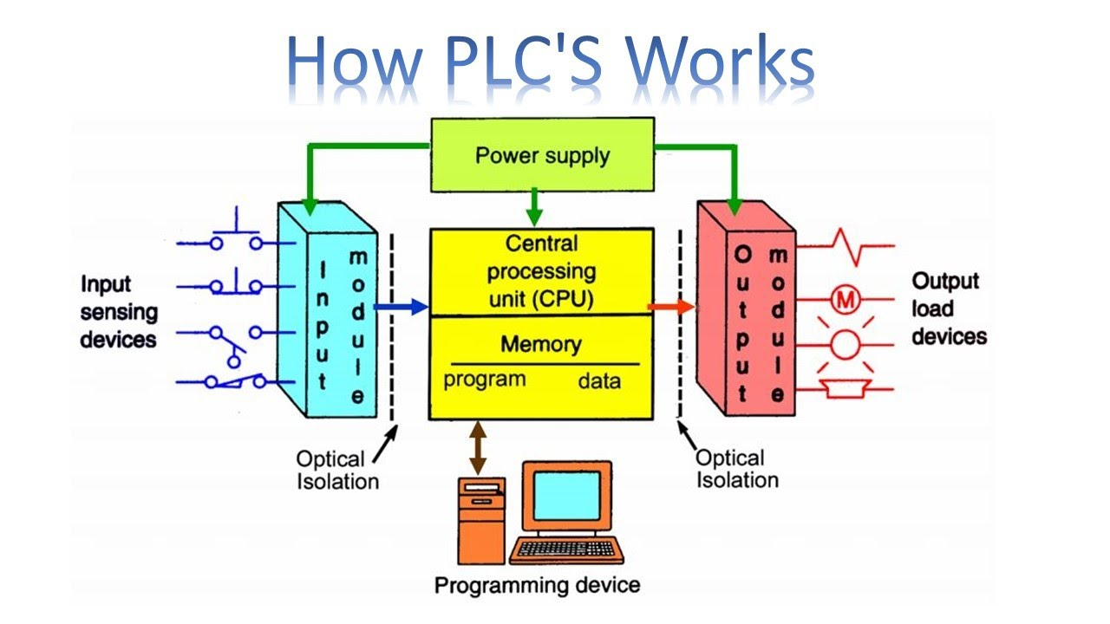

**The major functions of an I/O module fall into the following categories:**

**1. Control & Timing**

The control of the transfer of data from an external device to the processor might involve the following sequence of steps:

* The processor interrogates the I/O module to check the status of the attached device.
* The I/O module returns the device status.
* If the device is operational and ready to transmit, the processor requests the transfer of data, by means of a command to the I/O module.
* The I/O module obtains a unit of data (e.g., 8 or 16 bits) from the external device.
* The data is transferred from the I/O module to the processor.

**2. CPU Communication**

I/O module must communicate with the processor and with the external device. Processor communication involves the following:

* **Command decoding**: The I/O module accepts commands from the processor, typically sent as signals on the control bus. Example: READ SECTOR, WRITE SECTOR, SEEK track number and SCAN record ID
* **Data**: Data is exchanged between the processor and the I/O module over the data bus.
* **Status reporting**: Because peripherals are slow, it is important to know the status of the I/O module. Example: Common status signals are BUSY and READY
* **Address recognition**: Just as each word of memory has an address, so does each I/O device. Thus, an I/O module must recognize one unique address for each peripheral it controls.

**3. Device communication**

* The I/O module must be able to perform device communication. This communication involves commands, status information, and data.

**4. Data Buffering**

* Rate of data transfer to/from CPU is faster than to/from external devices
* I/O module buffers data so that peripheral can send/receive at its rate, and CPU can send/receive at its rate

**5. Error Detection**

* Must detect and correct errors that occur.

**4.2 ANALOG SIGNALS**

Analog signals are continuous signals that vary with time.  Each point on the wave has a precisely defined value. They can have infinite number of states. In many PLC’s an analog signal is represented by a word. A word in binary is 8 zeros in a row or two bytes i.e. 4 zeros. When the analog input signal enters the PLC, it goes through an A/D converter or analog to digital converter. This is the component in the PLC analog input card that transforms the analog signal to digital signals. Conversely, every analog output module contains a Digital-to-Analog Converter, circuit to convert the PLC’s digital command words into analog electrical quantities. Analog inputs can come from a variety of transmitters. The job of a transmitter is to transform that into an electrical signal.

**ANALOG INPUTS:**

* Level transmitter
* Pressure transmitter
* Temperature transmitter
* Flow transmitter
* Viscosity transmitter

**ANALOG OUTPUTS:**

* Pressure control valves
* Temperature control valves
* Level control valves
* Flow control valves
* Viscosity control valves

**4.3 DIGITAL SIGNALS**

A digital signal is a signal that is being used to represent data as a sequence of discrete values. This is also called binary signal or logical signal. They have only 2 possible states “on” or “off”. In most digital circuits, the signal can have two possible values. They are represented by two voltage bands one near a reference value typically termed as ground or zero volts and the other a value near the supply voltage. These correspond to the two values "zero" and "one". Inside each digital input module there is a set of light-emitting diodes (LED) which will be energized when the corresponding sensing device turns on. Light from each LED shines on a photo-sensitive device such as a photo-transistor inside the module, which in turn activates a bit inside the PLC’s memory. Opto-coupled arrangement makes each input channel of a PLC capable of isolating the sensitive computer circuitry of the PLC from transient voltage spikes and other electrical phenomena capable of causing damage.

**DIGITAL INPUTS:**

* Pressure sensors
* Level sensors
* thumbwheel switches
* limit switches
* Proximity switches
* Selector switches
* pushbuttons
* level switches
* Fans
* Lights

**DIGITAL OUTPUTS:**

* Alarms
* Control relays
* Fans
* lights
* Motor starters
* Solenoids

**5. SCADA**

**5.1 INTRODUCTION**

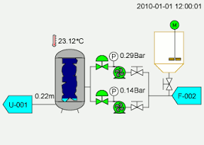

To understand the origin of SCADA, we must understand the problems industrial organizations are trying to solve. Before the concept of SCADA was introduced in the mid-20th century, many manufacturing floors, industrial plants, and remote sites relied on personnel to manually control and monitor equipment via push buttons and analog dials.

As industrial floors and remote sites began to scale out in size, solutions were needed to control equipment over long distances. Industrial organizations started to utilize relays and timers to provide some level of supervisory control without having to send people to remote locations to interact with each device.

While relays and timers solved many problems by providing limited automation functionality, more issues began to arise as organizations continued to scale out. Relays and timers were difficult to reconfigure, fault-find and the control panels took up racks upon racks of space. A more efficient and fully automated system of control and monitoring was needed.

In the early 1950s, computers were first developed and used for industrial control purposes. Supervisory control began to become popular among the major utilities, oil and gas pipelines, and other industrial markets at that time. In the 1960s, telemetry was established for monitoring, which allowed for automated communications to transmit measurements and other data from remotes sites to monitoring equipment. The term “SCADA” was coined in the early 1970s, and the rise of microprocessors and PLCs during that decade increased enterprises ability to monitor and control automated processes more than ever before.

Supervisory control and data acquisition (SCADA) is a system of software and hardware elements that allows industrial organizations to:

* Control industrial processes locally or at remote locations
* Monitor, gather, and process real-time data
* Directly interact with devices such as sensors, valves, pumps, motors, and more through human-machine interface (HMI) software
* Record events into a log file

SCADA systems are crucial for industrial organizations since they help to maintain efficiency, process data for smarter decisions, and communicate system issues to help mitigate downtime.

The basic SCADA architecture begins with programmable logic controllers (PLCs) or remote terminal units (RTUs). PLCs or RTUs are microcomputers that communicate with an array of objects such as factory machines, HMIs, sensors route the information from those objects to computers with SCADA software. The SCADA software processes, distributes, and displays the data, helping operators and other employees analyse the data and make important decisions.

For example, the SCADA system quickly notifies an operator that a batch of product is showing a high incidence of errors. The operator pauses the operation and views the SCADA system data via an HMI to determine the cause of the issue. The operator reviews the data and discovers that the particular machine was malfunctioning. The SCADA system’s ability to notify the operator of an issue helps him to resolve it and prevent further loss of product.

**5.2 SUB SYSTEMS**

* **SUPERVISORY COMPUTERS**

This is the core of the SCADA system, gathering data on the process and sending control commands to the field connected devices. It refers to the computer and software responsible for communicating with the field connection controllers, which are RTUs or PLCs, and includes the HMI software running on operator workstations. In smaller SCADA systems, the supervisory computer may be composed of a single PC, in which case the HMI is a part of this computer. In larger SCADA systems, the master station may include several HMIs hosted on client computers, multiple servers for data acquisition, distributed software applications, and disaster recovery sites. To increase the integrity of the system the multiple servers will often be configured in a dual-redundant or hot-standby formation providing continuous control and monitoring in the event of a server malfunction or breakdown.

* **COMMUNICATION INFRASTRUCTURE**

This connects the supervisory computer system to the RTUs or PLCs, and may use industry standard or manufacturer proprietary protocols. Both RTU's and PLC's operate autonomously on the near-real time control of the process, using the last command given from the supervisory system. Failure of the communications network does not necessarily stop the plant process controls, and on resumption of communications, the operator can continue with monitoring and control. Some critical systems will have dual redundant data highways, often cabled via diverse routes.

* **HUMAN MACHINE INTERFACE**

The human-machine interface (HMI) is the operator window of the supervisory system. It presents plant information to the operating personnel graphically in the form of mimic diagrams, which are a schematic representation of the plant being controlled, and alarm and event logging pages. The HMI is linked to the SCADA supervisory computer to provide live data to drive the mimic diagrams, alarm displays and trending graphs. HMI is the graphical user interface for the operator, collects all data from external devices, creates reports, performs alarming, sends notifications, etc.

Mimic diagrams consist of line graphics and schematic symbols to represent process elements, or may consist of digital photographs of the process equipment overlain with animated symbols. Supervisory operation of the plant is by means of the HMI, with operators issuing commands using mouse pointers, keyboards and touch screens.

For example, a symbol of a pump can show the operator that the pump is running, and a flow meter symbol can show how much fluid it is pumping through the pipe. The operator can switch the pump off from the mimic by a mouse click or screen touch. The HMI will show the flow rate of the fluid in the pipe decrease in real time.

**5.3 FUNCTIONS OF SCADA**

* **ALARM HANDLING**

An important part of most SCADA implementations is alarm handling. The system monitors whether certain alarm conditions are satisfied, to determine when an alarm event has occurred. Once an alarm event has been detected, one or more actions are taken such as the activation of one or more alarm indicators, and perhaps the generation of email or text messages so that management or remote SCADA operators are informed.

An alarm point is a digital status point that has either the value “normal” or “alarm” that is calculated by a formula based on the values in other analogue and digital points. The SCADA system might automatically monitor whether the value in an analogue point lies outside high and low limit values associated with that point.

Examples of alarm indicators include a siren, a pop-up box on a screen, or a coloured or flashing area on a screen that might act in a similar way to the "fuel tank empty" light in a car. In each case, the role of the alarm indicator is to draw the operator's attention to the part of the system 'in alarm' so that appropriate action can be taken.

* **DATA LOGGING**

Data logging is the process of collecting and storing data over a period of time in order to analyse specific trends or record the data-based events/actions such as the data's size, most recent modification and username/name of the individual that modified the data, of a system, network or IT environment. It enables the tracking of all interactions through which data, files or applications are stored, accessed or modified on a storage device or application.

For example, data logging can store processor temperature and memory utilization over time and network bandwidth usage. System/network administrators use this data to analyse system or network performance during a specific period.

Data logging also allows information security (IS) and auditing staff to analyse system access information and assess audit trails to trace viruses and identify suspicious activities.

* **DATA ARCHIVING**

Data archiving is the process of moving data that is no longer actively used. Archive data consists of older data that remains important to the organization or must be retained for future reference. Data archives are indexed and have search capabilities, so files can be located and retrieved. Archived data is stored on a lower-cost tier of storage, serving as a way to reduce primary storage consumption and related costs.

* **TRENDING**

SCADA system collects real time and historical time remote sensor data through PLC and plots the data on to an advanced charting system. It is very easy to use and allows clients to review and analyse data easily.

**5.4 APPLICATIONS**

* **Electric power system, operation and control:**

SCADA systems are used in electric power generation plants, transmission area and distribution system

* **Manufacturing Industries or plants:**

A SCADA helps in management of different inventory items or raw materials, controlling of automated systems in synchronous manner.

* **Telecom and IT based systems:**

Management of different RF based systems, communication mediums and large communication systems including data logging through antennas can be easily done through the SCADA

* **Water treatment plants and supply management:**

SCADA based systems are used by the state or Municipal Corporation to monitor, control and regulate water capacities in reservoir.

* **Traffic controls:**

SCADA helps in regulation of traffic signals, controls the traffic flow in railway systems on road systems and air traffic controls.

**5.5 ADVANTAGES**

* Cheaper
* Continuous Operation
* Reliable
* Improves maintenance Operation
* Few Operators Control large number of Assets
* Provide rapid response to Emergencies
* Long Distance Monitoring.
* Data Management
* Automated Operations with real time control

**5.6 DISADVANTAGES**

* Troubled alarms
* Lack of Trained Persons
* Initial capital Investment

**6. INSTRUMENTATION**

**6.1 Definition:**

The definition of Instrumentation is – a collection of instruments or their application for the purpose of observation, measurement or control.

Process Measurement:

* Pressure
* Temperature
* Flow
* Level

**6.2 Pressure Measurement:**

* Pressure is the force exerted per unit area
* Pressure is the action of one force against another force. Pressure is force applied to, or distributed over, a surface. The pressure P of a force F distributed over an area A is defined as P = F/A.



**Types of Pressure Measurement:**

* Liquid column.
* Mechanical gauges.
* Electronic Pressure sensors.

**Electronic Pressure Sensors:**

* More reliable, more accurate than many mechanical measuring instruments
* Two types of pressure sensors are:
* Strain Gauges
* Variable Capacitor Pressure Detector

**Piezo- Resistive Strain Gauge:**

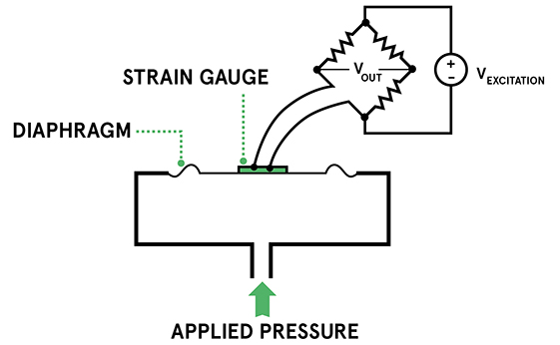

* Piezoresistive strain gauges are among the most common types of pressure sensors. They use the change in electrical resistance of a material when stretched to measure the pressure.
* The basic principle of the piezoresistive pressure sensor is to use a strain gauge made from a conductive material that changes its electrical resistance when it is stretched. The strain gauge can be attached to a diaphragm that recognizes a change in resistance when the sensor element is deformed. The change in resistance is converted to an output signal

There are three separate effects that contribute to the change in resistance of a conductor. These are:

* The resistance of a conductor is proportional to its length so stretching increases the resistance
* As the conductor is stretched, its cross-sectional area is reduced, which also increases the resistance
* The inherent resistivity of some materials increases when it is stretched

**CAPACITIVE PRESSURE SENSORS:**

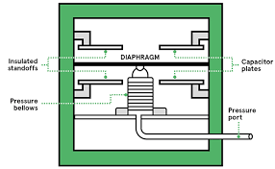

Capacitive pressure sensors measure pressure by detecting changes in electrical capacitance caused by the movement of a diaphragm. Important parameters in changing the capacitance are

* εr is the dielectric constant of the material between the plates (this is 1 for a vacuum)
* ε0 is the electric constant (equal to 8.854x1012 F/m),
* A is the area of the plates
* d is the distance between the plates

Changing any of the variables will cause a corresponding change in the capacitance. The easiest one to control is the spacing. This can be done by making one or both of the plates a diaphragm that is deflected by changes in pressure.

Typically, one electrode is a pressure sensitive diaphragm and the other is fixed

**6.3 Temperature Measurement:**

Temperature is measure of how hot or cold something is; specifically, a measure of the average kinetic energy of the particles in an object, which is a type of energy associated with motion.

Units:Kelvin, Celsius, Rankine

**Measurement methods:**

* Resistance temperature detector (RTD)
* Thermistor
* Thermocouple
* Bimetallic thermometer
* Pyrometry

**Resistance temperature detector (RTD):**

RTDs (Resistance Temperature Detectors) operate under the principle that the electrical resistance of certain metals increases and decreases in a repeatable and predictable manner with a temperature change.

***Basic Principle of RTDs:***

The relation between resistance and temperature is Rt = R0 (1 + α t)

Where,

R = Change in resistance (R2-R1)

α = Thermal coefficient of Metal

ΔT = Change in temperature (T2-T1)

**RTD Elements:**

*Wire Wound Element:*

Precise lengths of wire are wrapped around a ceramic mandrel, then

Shell which acts to support and protect the wire windings.



*Inner Coil Element:*

Wires are coiled then slid into the holes of a ceramic insulator. Some manufacturer’s backfill the bores with ceramic powder after the coils are in against each other. Inserted inside a ceramic instead. This keeps the coils from shorting.



**Thermocouple:**

* Thermocouples are based upon an effect called galvanic action.
* A thermocouple consists of two pieces of dissimilar metals with their ends joined together (by twisting, soldering or welding). When heat is applied to the junction, a voltage, in the range of milli-volts (mV), is generated. A thermocouple is therefore said to be self-powered.

***Physical principle:***

**See beck effect:**

* Dissimilar metal junction subject to a temperature.
* EMF is generated proportional to temperature.

***Factors for Selecting Thermocouple Type:***

There are many kinds of thermocouples, and each is made up of different types of metals. The choice of a thermocouple type generally depends upon:

* Process conditions
* Temperature range to be measured
* Durability requirements
* Level of accuracy required

**Advantages of Thermocouples:**

Thermocouples are used widely in industry because they:

* Are rugged
* Can be used over a wide range of temperatures
* In general, thermocouples are used exclusively around the turbine hall because of their rugged construction and low cost.

**Disadvantages of Thermocouples:**

* Thermocouples are slower in response than RTDs.
* If the thermocouple is located some distance away from the measuring device, expensive extension grade thermocouple wires or compensating cables have to be used.

**6.4 Flow Measurement:**

**Various Types of Flow Measurement:**

*Differential Pressure Type:*

* Orifice Plate - Concentric, Eccentric, Segmental, Quadrant Edge, Integral,
* Conditioning
* Venturi Tube
* Flow Nozzles
* Elbow
* Pivot Tube, Averaging Pivot Tube (Annubar)
* Variable Area (Rota meter)
* Wedge Meter
* V-Cone
* Mass Type – measures the mass flow rate directly:
* Coriolis
* Thermal
* Velocity Type:
* Magnetic
* Ultrasonic - Transit Time, Doppler
* Turbine
* Vortex

Open Channel Type:

* Weir
* Par shall Flume

*Other Types:*

* Positive Displacement.

**6.5 Level Measurement:**

In space programme, liquid level determination is essential for propellant loading, management and utilization and to other diagnostic or control functions such as engine cut off.

*They are classified into:*

* Point liquid level sensors
* Hot wire
* Capacitance
* Optical
* Acoustic
* Continuous liquid level sensor.
* Direct weighing scheme
* Differential pressure
* Capacitance
* Acoustic
* Nuclear radiation attenuation.

***Raspberry Pi :-***

* The Raspberry Pi is a low cost , credit card sized computer that plugs into a computer monitor or TV, and uses a standard keyboard and mouse.
* It is a capable little device that enables people of all ages to explore computing and to learn how to program in languages like scratch and python.
* This board consists o a 1.2GHz 64-bit quad-core ARM processorand an 802.11n wireless LAN ,Bluetooth 4.1 and Bluetooth low energy.
* It consists of 1GB of RAM, 4USB ports , and full HDMI support.

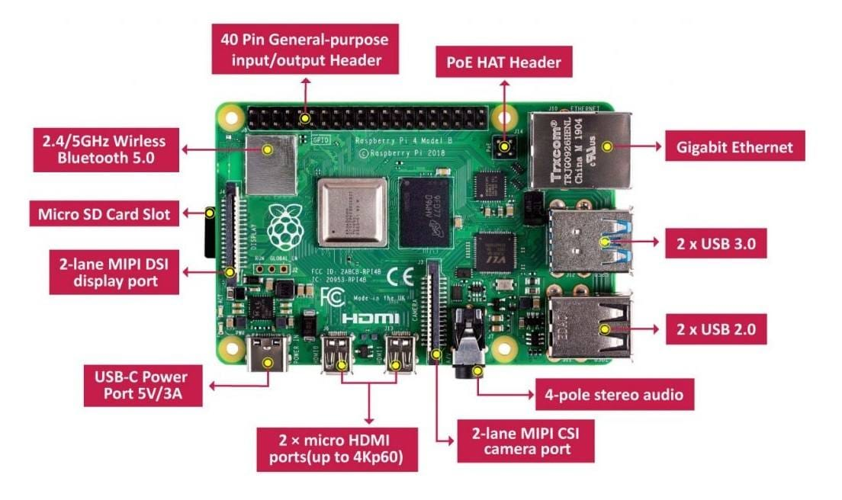

***Specifications of Raspberry Pi Board :*-**

* Quad-core 1.2GHz Boardcom BCM2837 64bit CPU.
* 1GB RAM
* BCM43438 wireless LAN and Bluetooth Low Energy on board.
* 100 Base Ethernet
* 40 pin extended GPIO
* 4 USB 2 Ports
* 4 poles 3.3mm stereo output and composite video port
* Full-size HDMI Camara Serial Inerface camara port for connecting camaras
* Micro SD port
* Micro USB Power port(up to 2.5A)
* Size- 85x56x17mm

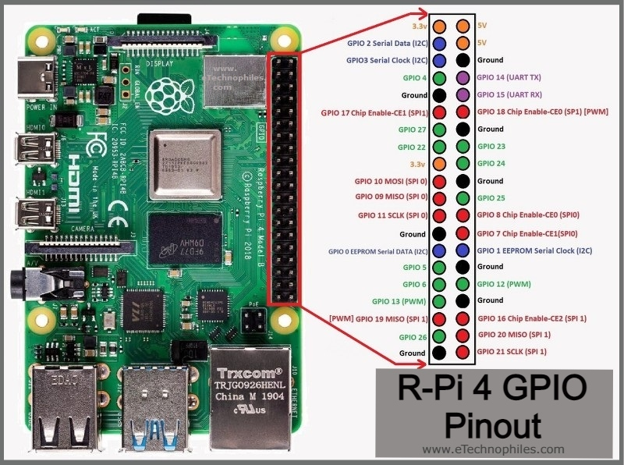

**7. PROJECT**

***Server Racks* :-**

* The server racks consists of many servers which Runs continuously.
* Up to certain temperature , the servers can able to run without any trouble. If that temperature rises , it may effect the performance of the servers.
* To avoid this conflict , an internal AC is provided inside the server racks to cool the servers.
* It maintains at the temperature of 24o C with accuracy of +1o C.
* There will be an inbuilt controller which detects the rise in temperature .
* If there is any problem with AC or the rise in the internal temperature in the rack, the controller detects it and immediately it opens the door.

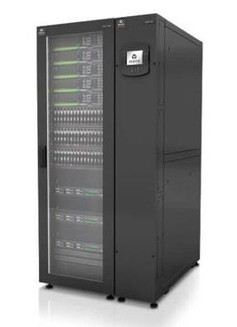

**Objective :-**

* To understand briefly, we are going to check the rise in temperature by using Raspberry pi controller.
* We need to check whether it can able to give sign of change in temperature by making the LED glow at the rise in temperature.

**1) AIM:**

To establish the communication between the Master and Slave systems.

**APPARATUS:**

* A master system
* RS422 cable
* Raspberry pi 4B board
* A slave system
* LED
* Connecting wires

**SOFTWARE USED:**

* Pymodbus
* Diagslave
* GPIO module

**TYPICAL SCADA SYSTEM:**

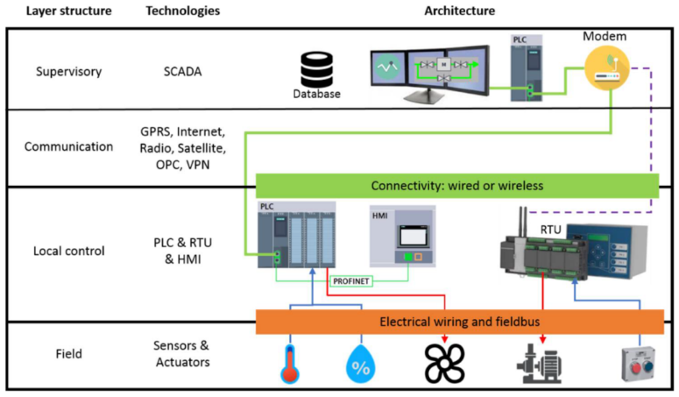

**CODE USED:**

**Master:**

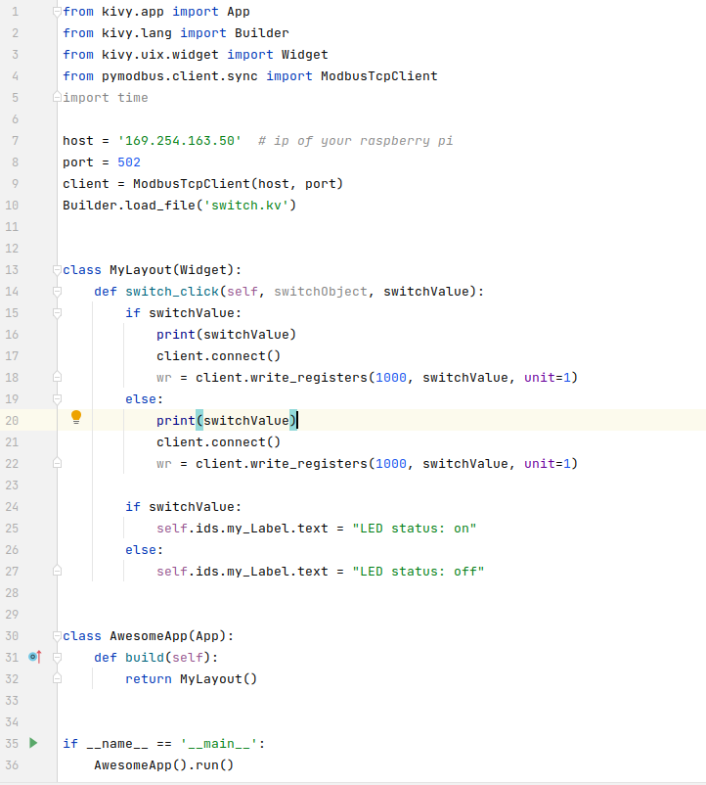

**User interface:**

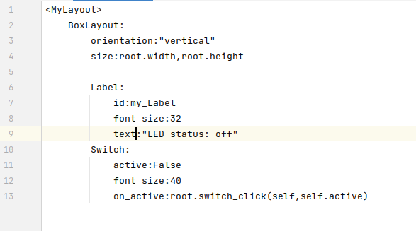

**Slave:**

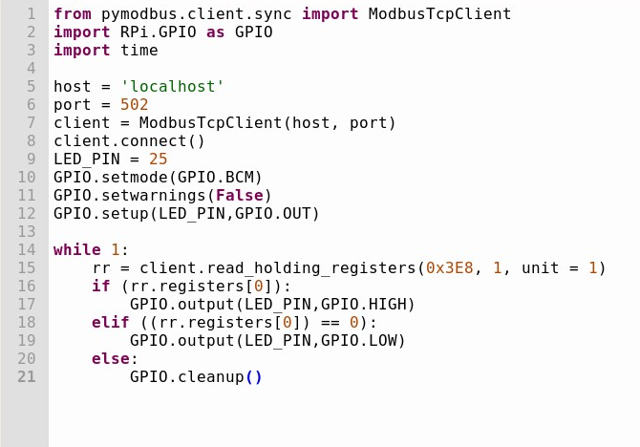

**PROCEDURE:**

1. First in order to establish a connection between the LED and raspberry pi select a pin and configure it to output pin and connect the pin to the LED
2. In case of the connection between master and slave use the RS422 cables
3. Run the following python code in the master system
4. Run the following code in the slave system
5. Then we have to give the digital command ON/OFF to check whether the communication between master and slave system is established or not.

**OBSERVATIONS:**

As the code from the slave system executes indefinitely as the code in an actual PLC does it checks up on the 1001 register for a value and based on the value provided by the master (either on or off) the slave sets the state of the LED to either HIGH or LOW.

Networkprotocols:

|  |  |  |
| --- | --- | --- |
| **SYSTEM MEMBERS** | **SCADA** | **PROJECT** |
| I/O -> PLC | TCP/IP | SERIAL |
| PLC -> SCADA | MODBUS | MODBUS |

**RESULTS:**

**Images showing different states of the bulb**

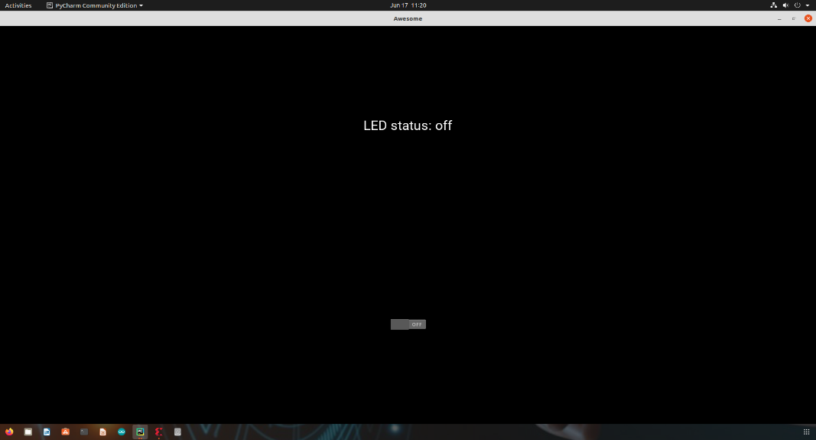

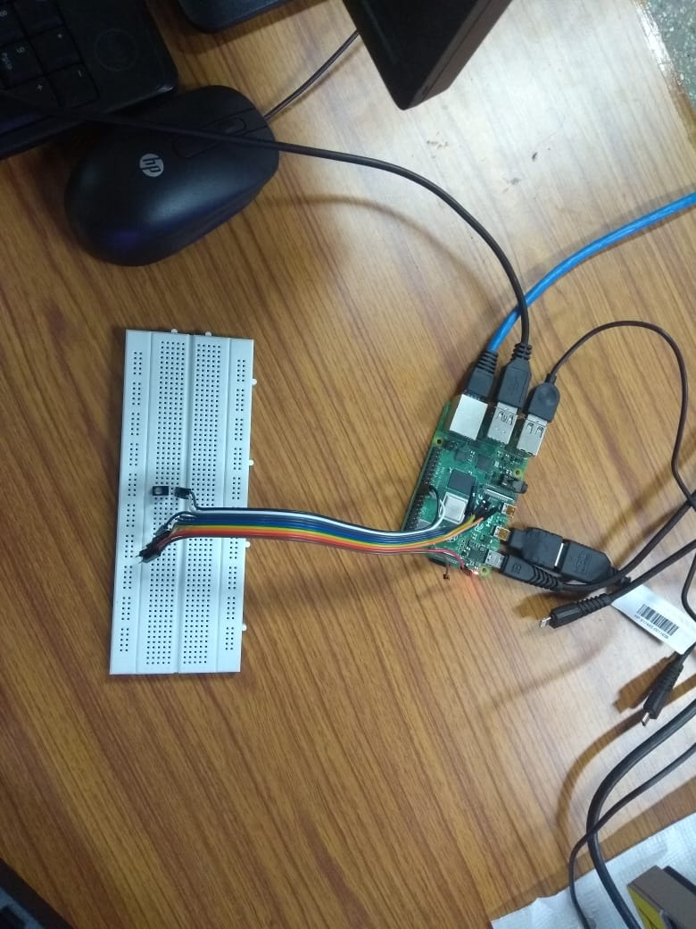

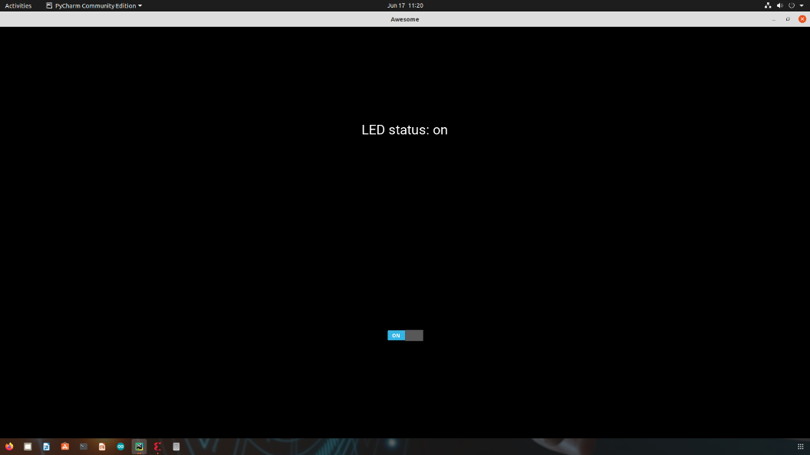

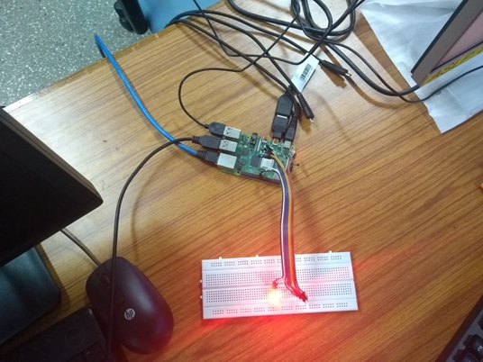

**Raspberry pi reading the value on the register 1001**

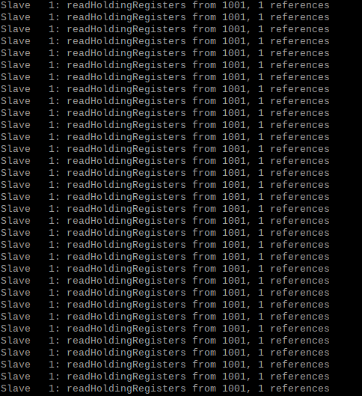

**CONCLUSION:**

From this project we are able demonstrate the process of communication between different layers of the system.

**2) AIM:**

To Detect the rise in temperature and send responseto the client system using a raspberry pi board.

**APPARATUS:**

* A Server system
* RS422 cable
* Raspberry pi 4B board
* A Client system
* LED
* Connecting wires

**SOFTWARE USED:**

* Pymodbus
* GPIO module

**CODE USED:**

**Client:**

import socket

import threading

import time

HOST = '169.254.163.50' # The server's hostname or IP address

PORT = 65432 # The port used by the server

def my_client():

threading.Timer(1, my_client).start()

with socket.socket(socket.AF_INET, socket.SOCK_DGRAM) as s:

my = "Data"

my_inp = my.encode('utf-8')

s.sendto(my_inp,(HOST, PORT))

data = s.recv(1024).decode('utf-8')

x_temperature, y_cutoff, z_led = data.split(",")

temperature = float(x_temperature)

cutoff_temperature = float(y_cutoff)

print("Temperature {} C".format(x_temperature))

print("cutoff_temperature",cutoff_temperature)

print("LED ON" if int(z_led) else "LED OFF")

print("\n")

s.close()

time.sleep(1)

if __name__ == "__main__":

while 1:

my_client()

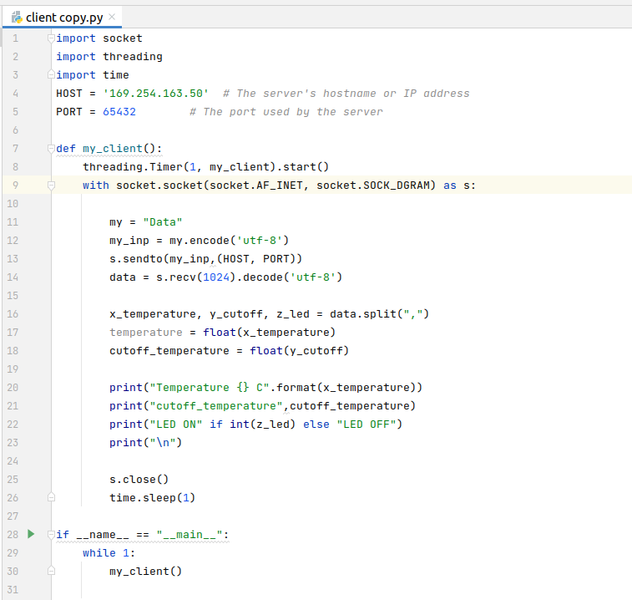

**Server Code:**

from gpiozero import CPUTemperature

import RPi.GPIO as GPIO

import socket

import numpy as np

import encodings

import time

HOST = '169.254.163.50' # Standard loopback interface address (localhost)

PORT = 65432 # Port to listen on (non-privileged ports are > 1023)

cpu = CPUTemperature()

LED_PIN = 25

GPIO.setmode(GPIO.BCM)

GPIO.setwarnings(False)

GPIO.setup(LED_PIN,GPIO.OUT)

led_do = 0;

def server_data():

temperature, cutoff_temperature = cpu.temperature, 54

if temperature is not None:

print("Temperature =",temperature,"C")

if temperature > cutoff_temperature:

led_do = GPIO.HIGH

else:

led_do = GPIO.LOW

GPIO.output(LED_PIN,led_do)

data = '{},{},{}'.format(temperature,cutoff_temperature,led_do)

return data

def my_server():

with socket.socket(socket.AF_INET, socket.SOCK_DGRAM) as s:

print("Server Started waiting for client to connect ")

s.bind((HOST, PORT))

s.setblocking(False);

while True:

my_data = server_data()

try:

data,address = s.recvfrom(1024)

if str(data.decode('utf-8')) == "Data":

print("data request from client ")

x_encoded_data = my_data.encode('utf-8')

s.sendto(x_encoded_data,address)

elif str(data) == "Quit":

print("shutting down server ")

break

if not data:

break

else:

pass

except:

print("")

time.sleep(1)

if __name__ == '__main__':

while 1:

my_server()

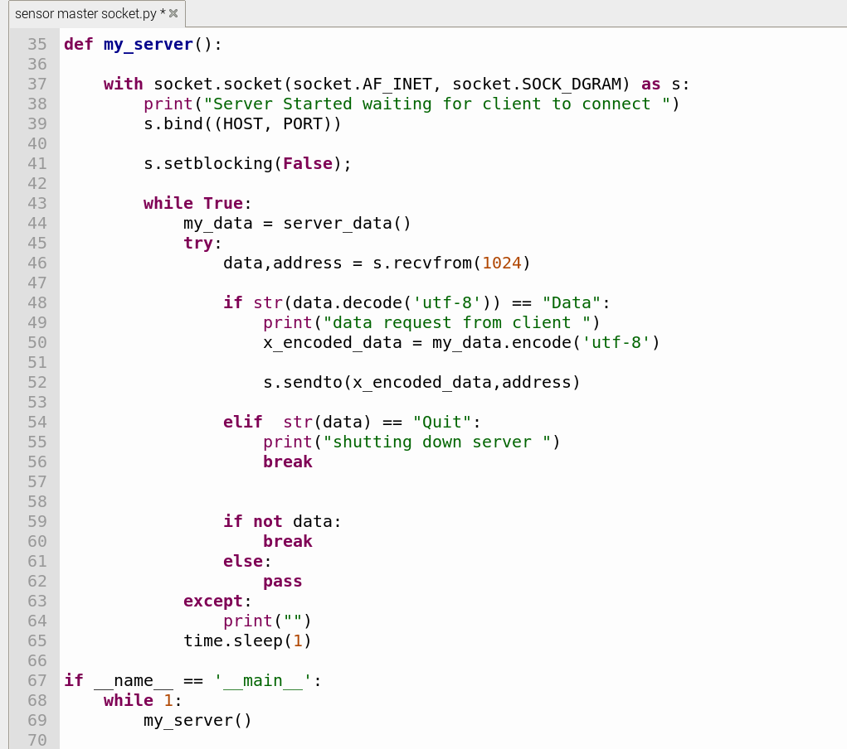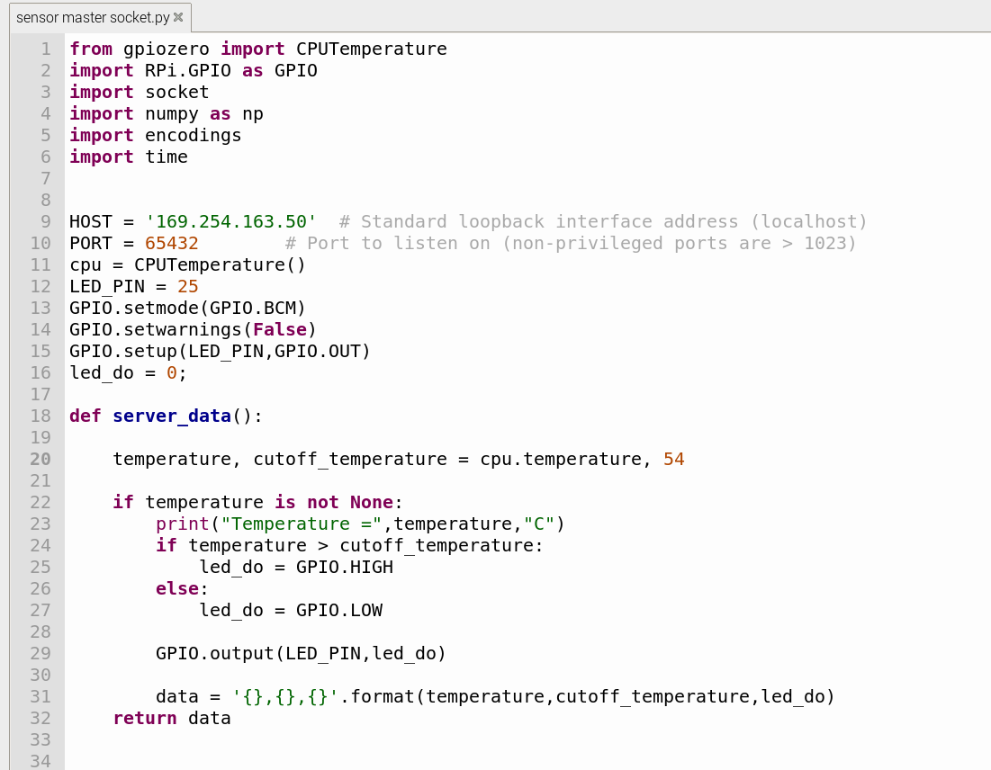

**PROCEDURE:**

1. First in order to establish a connection between the LED and raspberry pi, select a pin and configure it to output pin and connect the pin to the LED
2. In case of the connection between Server and Client use the RS422 cables
3. Run the following python code in the Server system
4. Run the following code in the Client system
5. Give a cut off temperature, such that the server san detect the change in temperature and send the response to the client system.
6. If the temperature exceeds the cut off temperature then the client receives the response that LED is ON , or else no response is received by the client .

**OBSERVATIONS:**

As the code from the Server system executes, the client system automatically connects to the server and acquire the temperature data from the server. The client show the status of LED such that if the temperature of the Raspberry pi exceeds the cut-off temperature of the server given , then the LED starts glow or else it is in OFF.

**RESULTS:**

**LED When the Temperature is less than the cutoff temperature:-**

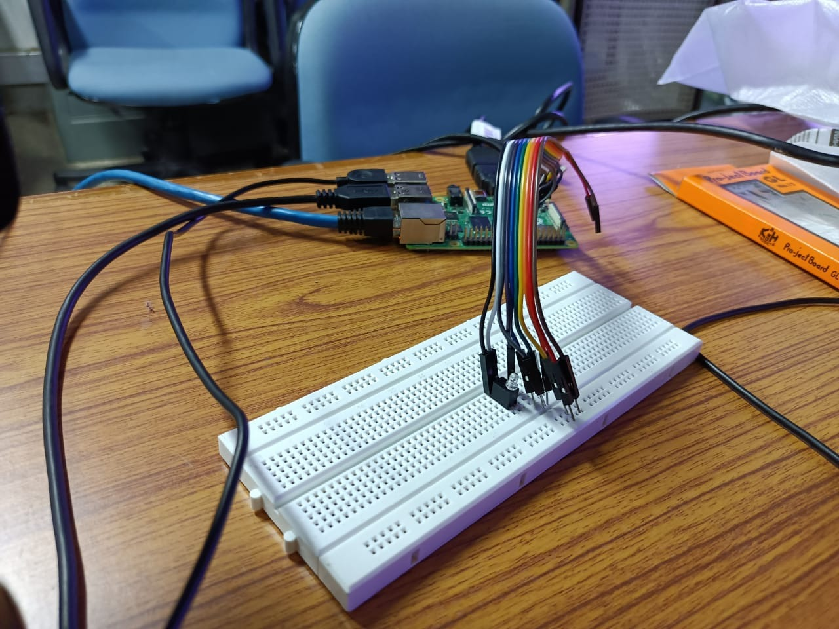

**LED When the Temperature exceeds the cutoff temperature:-**

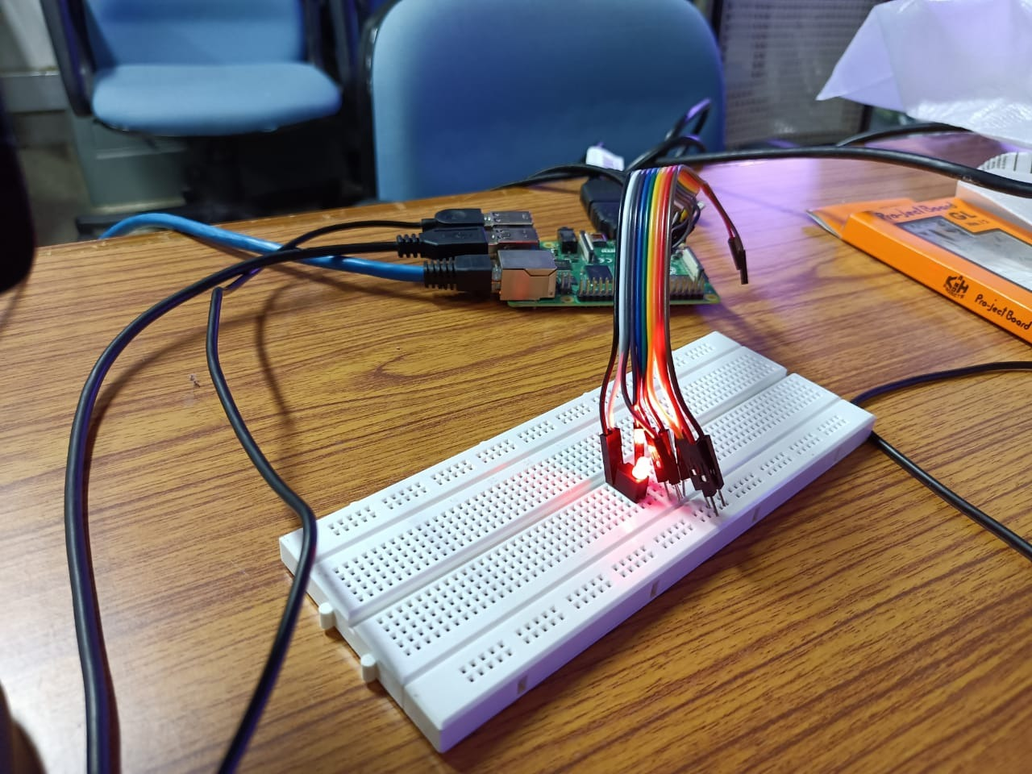

**Client output :**

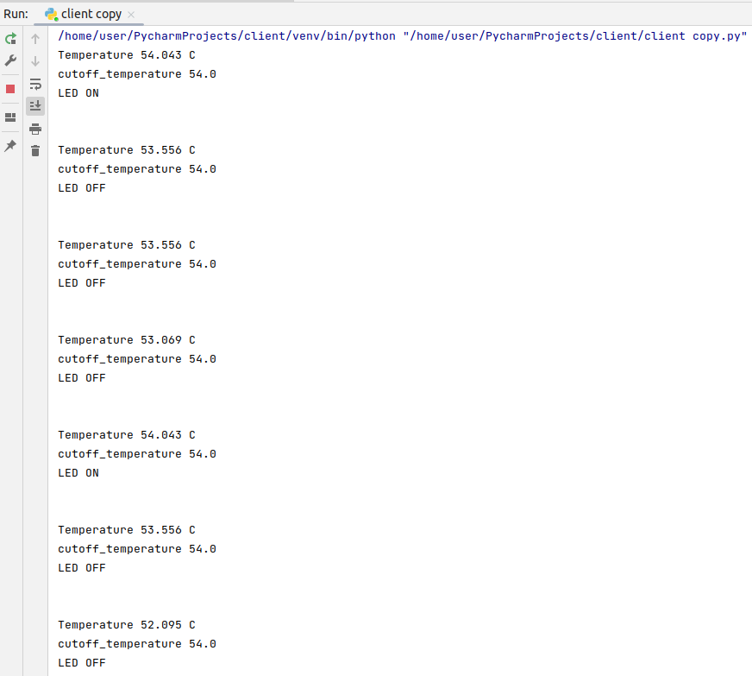

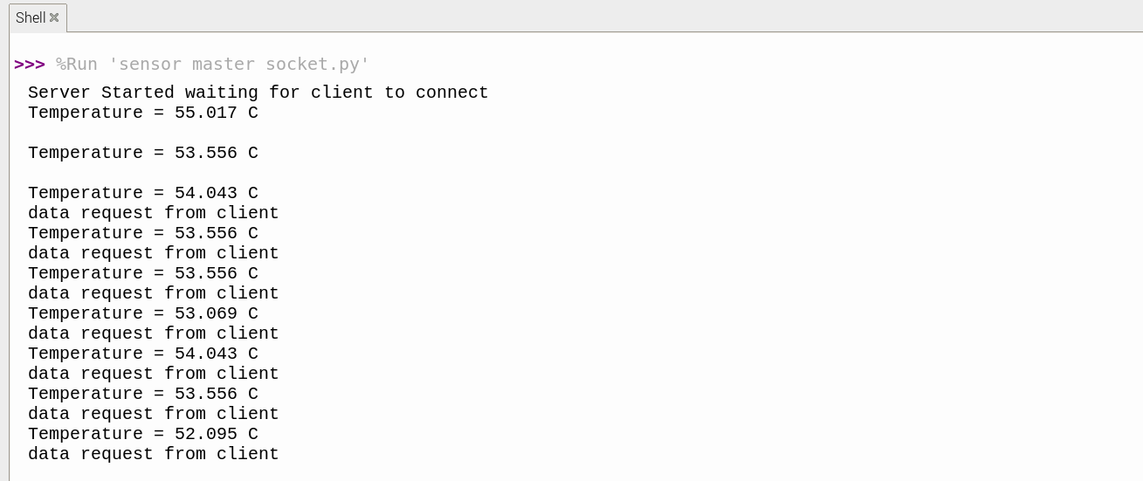**Server output :**

**CONCLUSION:**

From this project we are able to detect the rise in temperature and able to send the response to the client system through Raspberry Pi.